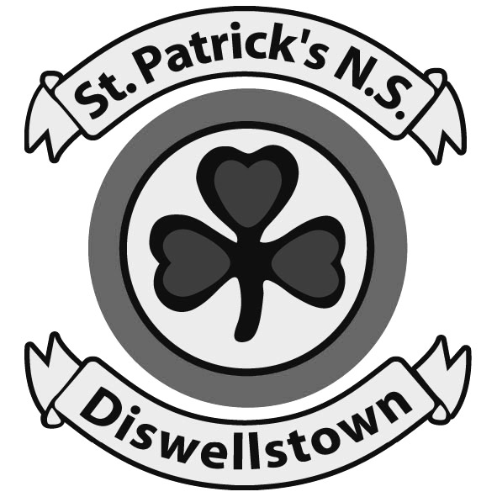

PARENTS’ ASSOC. NEWSLETTER
Hello to all our Parents, Children, Teachers and Staff. We have revived our St Patrick’s NS PA Newsletter as we feel it’s important to provide regular updates on the ongoing work of the Parents Association, as well as providing any relevant news stories that may be of interest to all of us within the school community.

OUR PURPOSE
The St. Patrick’s NS Parents Association is a group of Mums and Dads who work to assist the school Principal, staff and Board of Management with the development of St. Patrick’s National School. Two members of the BOM are also members of the Parents’ Association. We meet once every month and our primary function is to organise fundraising. We are not a profit making organisation at all. Every cent of the money that we raise goes directly back into the school.

We organise information evenings for parents have also supported the school with many initiatives such as the “clay-hand art project” that can be seen on the wall in the school entrance. Such events have helped the parents and children alike to feel engaged in the wider school community. We even provide funding for the little luxuries, like the visit by Santa’s little helper, where he gives goodies to every child in the school. Obviously, the schools requirement for funds increases year on year and even more so now that we are in the new building.

ST. PATRICK’S NATIONAL SCHOOL PARENTS ’ ASSOCIATION
NEWSLETTER - DECEMBER 2006

OUR PURPOSE (Cont’d)
We would like to take this opportunity to thank you for your immense support over the years and ask that you please continue to help and support our fund raising efforts in any way you can. With your continued support of our fundraising events throughout the year we can maintain the very high standard that we have achieved so far.

PARENTS’ ASSOCIATION AGM 2006
We held or 2006 AGM on 26th October. Thank you to all those parents who took the time to attend. Many issues were raised at the meeting, all of which have been noted and are currently under discussion. We hope to have an update on these for you in the next issue of the Parents Association Newsletter.

SANTA VISIT TO ST PATRICK’S ON FRIDAY 22nd DECEMBER
This news is for the most important members of our school community……our children.


Santa Claus will be making a very special visit to our school on Friday 22nd December. He knows that all the boys and girls have been very good this year and as always he is really excited about meeting everybody.

Santa is especially looking forward to visiting our new school, as this is our first Christmas in our wonderful new school building. No doubt Santa will get a very big St Patrick’s welcome!!

FUND RAISING NEWS

FUNDRAISING – SEPT TO DEC 2006
€
Proceeds of Fashion Show 8,756.00
Proceeds of Sponsored Walk 9,852.00
Total raised to date 18,608.00
LESS Funds Spent Sept – Dec 2006 3,856.00
Current Balance of Funds 14,752.00

FUTURE FUND RAISING EVENTS 2007
We are planning several fund raising events for the new year – a Pub Quiz, a Golf Classic, a Social Night, to name but a few. We’ll be keep you posted in the new year with more details of our upcoming events.

HOW TO CONTACT US
If you have any queries or suggestions, please contact any of the Parents Association members listed below:
Marie McCarthy (Chairperson)
Patricia McGinnell (Secretary)
Dessie Kearney (Treasurer)
(A complete list of PA members is available on request).

SCHOOL “CLASS” CALENDARS
For those who are not already familiar with our class calendars, each Christmas the Parents’ Assoc produces a calendar of each class in the school. At a cost of €5.00 each, they make an excellent Christmas gift for grandparents, aunts, uncles etc. All proceeds go to the school so please support this worthy cause.

A big thank you to Robert, Donie, Paul and all those who helped out in producing the calendars.

And most of all, well done and thank you to all the children whose smiling faces helped produce such wonderful class photographs.

POST PRIMARY SCHOOL
St Patrick’s National School Diswellstown was established in 2000. Its first intake of students in 2000 was 2 classes of Junior Infants of ~60 pupils, since that initial intake it has grown to 3 and 4 classes per year.
Demand for primary school places in the Castleknock area is strong, with 2 new schools and major expansions to 2 existing primary schools within the last 7 years.
Given the strong demand for primary school places, the Board of Management and Parents Association became concerned at the situation that may arise as our students transition from primary to post primary education. We wrote to Castleknock Community College to clarify the situation. From the response received it is clear that demand will exceed the supply of local post primary places.
St Patrick’s Parents Association worked with the Parents Association of primary schools in the current catchment’s area of Castleknock Community College, to build a consensus on a new post primary school in the Castleknock area.
Having developed that consensus, the proposal was presented to all primary schools’ Boards of Management and Parents Associations in the current catchment area of Castleknock Community College, who endorsed the proposal.
The proposal was presented to the school planning section of the Department of Education & Science on October 2nd 2006. We appeared to adequately address the demand and ethos for a new post primary school, however 2 issues remain:
- The site
- The support of a recognized patron body for post primary schools
We have met and formally requested the County Dublin Vocational Educational Committee to become patron of this proposed second community college for Castleknock.
The next big issue is finding a suitable site, where we hope Fingal County Council will help.
We need all parents to raise the school places issues when candidates in the general election come canvassing for your vote.


We wish everybody a very happy Christmas, and peaceful and happy New Year.

