June Newsletter

School Closes for Summer Break.
Children will finish at 11.30am on Thursday 30 June

6th Class Graduation
As advertised in our May newsletter, our 6th classes will graduate next Tuesday night (see times below). While we are very excited to return to an in person event, we are also conscious that covid is circulating widely among the school community. We would strongly recommend and appreciate it if attendees wear masks. Please remember we can only accommodate graduate + 2 guests.
6.30 pm (Ms. Kenny / Ms. Lydon)
7.45pm (Ms. Donnelly /Ms. Antal)
6th Class Guard of Honour
Parents are welcome to collect their 6th class child from the area inside the main school gate (adjacent to artificial grass) on their last full day of school in St.Patrick’s on Wednesday 29th June. The older classes will form a Guard of Honour and the 6th classes will be released @1:45 on this day. School remains open for all on the last day (June 30th).
**Aladdin App – 6th Class Pupils**
Please note that if your 6th class child is your youngest child, you will only have access to Aladdin until 30 September 2022. If you have not downloaded/printed your child/children’s school reports before this date, you will no longer have access.

PA Family Quiz
We are all looking forward to our Family Quiz which will go ahead on Sunday 26th June at 2pm!
Please see separate mail from Parents’ Association for final details.

Lost Property
Any unclaimed Lost Property items will be donated to St Vincent de Paul if not collected by Thursday 30th June. Please note Lost Property items will be on display under the Foyer. See picture below of unclaimed items including pile of unlabelled jumpers. 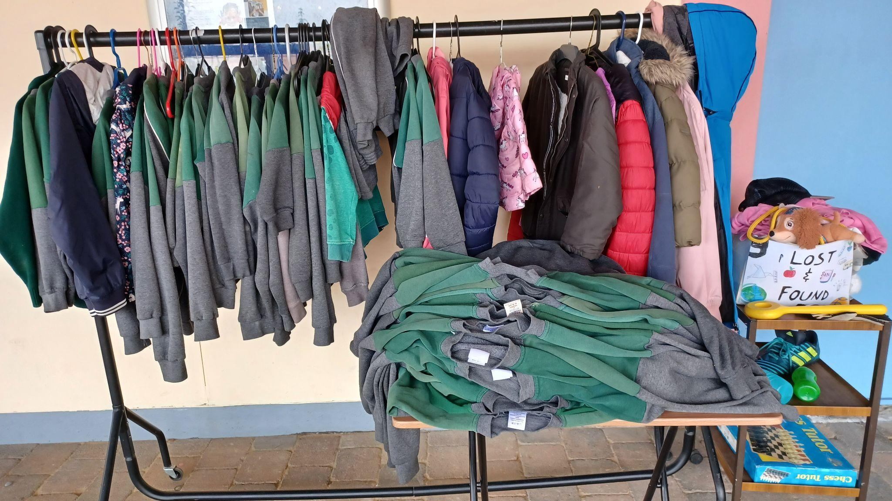

Boys Football
We really enjoyed playing football for the school team. Our games have been great fun and hopefully entertaining to watch. We have had great results in all our games managing to top the group. Sadly we only have one game remaining but we hope to finish on a high.
Zac Coyne and Toby Stacey
Cricket
In the last few weeks,many of the girls and boys in 6th class went to cricket coaching sessions with Brian O’Rourke, Cricket Development Manager for Fingal in Castleknock College. We started off with some batting and bowling drills. Some of the children got picked to play a match against a local school. Sadly the team didn’t show up on he day so we replayed the drills using the hardball and protective gear.. It was great fun! Personally, I (Conor) loved it so much that I joined a Cricket Club, Phoenix, in the Phoenix park and I really enjoy it.
Conor McAuliffe and Zac Cooney
Story Teller
A story teller came, his name was Niall de Burca. He was very very funny. We like the way he didn’t read from a book, he had his own story. He did a lot of different voices and sounds. He told the story in the PE Hall. We would all watch him all day. That's how funny he was. He was very entertaining. When we walk into the hall there was a library so we thought he was reading from a book. But he wasn’t. He was really good and we would 100% listen to him again.
Thank you to the Parents’ Association for supporting this event.
Leah O’Callaghan, Ava Breen & Sadie Donnelly- Ms McTauge’s 4th Class

ATP/PSI Committee - Bottle Top Mural
The ATP/PSI Committee and many volunteers are helping us to finish our bottle top mural, which we designed at our meetings this year. We can not wait to have the bottle top mural for you all to see at the garden area. We have put a lot of time and effort into this project. We are very thankful for the help of the volunteers and the committee that have given their time to get this project.
Louis Hanbury, Chinmay Kumar, Sam Cantle.
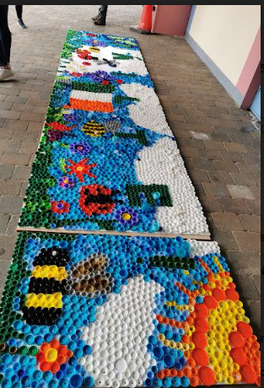

Fairy Tale Mural
We heard that the school wanted the ATP/PSI Committee to paint a mural for the Story Telling Area. We were talking at break time and the idea just came to us of a design for the space, of an open book with rainbows and fairy tale characters. Sophie drew it out and gave it to the ATP who agreed to the design. The Committee came to the school one evening, when it was still dark, and projected the design onto the wall and we sketched it out. We started painting on a Saturday in May and completed it a month later. The official opening was last Tuesday when the storyteller Niall De Burca came to the school to tell us all a story. We are delighted with the result and we are thankful to the ATP, Mr MacConámha, the PA and volunteers for their help to bring our idea to life. We are happy to leave our mark on the school as we are leaving this year!
Sophie Rigney, Bea O’Brien, Sarah McCague and Lucy Stack - Ms Donnelly’s 6th Class
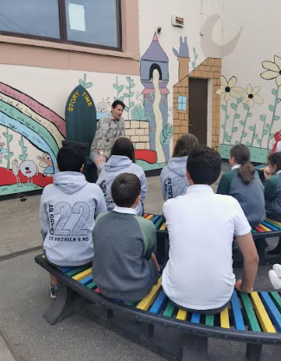
The Student Council
The Student Council has started back up again. We have achieved many things over the past few months such as a fundraiser for yard equipment, raising over €1200. We donated €200 to the Castleknock GAA to locals helping Ukrainian people who have recently come to Ireland. The other money was spent on polydrons and storage boxes for the yard. Intel has kindly donated some funding to the school and the Student Council have selected some benches that will likely arrive early next year and be placed on the yards. We have enjoyed being part of the Student Council this year.
Caoimhe Keelan, Vanessa Ng and Alannah O’Brien - Student Council Members
Reminders

Extras Fees
Thank you to everyone who have paid their Extras Payment. The Extras Payment of €75 per child is now payable through Aladdin. During the 2021/2022 school year, we rely on this for :
· Replacement of shared textbooks
· Classroom Resources for Literacy, Numeracy, Gaeilge, Science, History, Geography,PE, RE, SPHE, Visual Art, Drama and Music
· Stationery (pencils, crayons, copybooks, book boxes, etc) for all pupils.
· Photocopying
· Guided and Shared Readers, classroom novels
· IT Resources
· Insurance- 24 hour personal cover for all pupils (www.allianz.ie/schools) which costs €6.50 per pupil.
· Seesaw, Reading Eggs and Mangahigh subscriptions
We are a cashless school. Our Online Payment System allows parents to pay in a secure manner, using your ATM/Debit/Credit card. It will also automatically enter the record of the payment against your child's record on our school database. An email or text will issue to parents with all outstanding payments automatically listed.
We have set up the payment request so that you can pay in installments if you wish. When you click into the link, there will be a payment on the screen for €75 for Extras Payments 2020-2021. Under the €75, you will see the word "change". Click on "change" and input the amount you wish to pay at this time. Minimum payment is €10 per each installment.

School Communication
It costs approximately €95 to send one text to each family in the school. By using Aladdin Connect, we save money on communication costs. If you have not yet engaged with Aladdin Connect, we ask that you do as soon as possible. It should be noted that if two parents are using the one sign in, only the first to open notifications will see the communications being sent. Aladdin had always recommended that both parents engage with separate Apps. By not engaging, you are missing lots of important information for your child/children. For example, notifications informing you of changes in closing times, upcoming events, permission requests for activities, e.g. GAA Football, Hurling and Camogie, Soccer, Athletics. Tour notifications, Illness notifications, e.g. Covid, Chickenpox, Headlice, etc.etc. You should also note that School Reports are only accessible via Aladdin.
If you need us to reset your account or resend your access code, please email info@stpatricksns.ie with your name and your child/children’s names.
If you are having problems setting up Notifications, please use this link https://aladdin.ie/files/pdf/Quick%20guide%20-%20If%20a%20parent%20is%20not%20receiving%20notifications.pdf

Permissions Requests
Permissions Requests are made throughout the year for various reasons e.g. Tours. It is very important that when Permission requests are made that they are responded to promptly by either ticking “consent” or “decline”. Please ensure you have your Aladdin notifications enabled to ensure your prompt receipt. Thank you for your cooperation in this important matter.

Letters of Attendance
We would ask that if you require Letters of Attendance for Child Benefit/Travel/Visa purposes for your child/children, that you give the office as much advance notice as possible. Please EMAIL your request to info@stpatricksns.ie stating the purpose of the letter.

· Diswellstown Community Centre & Local Area Activities

CASTLEKNOCK GAA

Sports in Tir na nÓg Park (D15 A996) every Thursday from 6.30pm to 7.30pm for Children recently arrived from Ukraine aged 5years+ (must be accompanied by an adult or guardian). On arrival sign up at registration table. Minibus leaves travel Lodge at 6pm or from Blanchardstown Shopping Centre take 37 Dublin Bus to stop 4893. Looking forward to welcoming you.

SELF ESTEEM, THE KEY TO YOUR CHILD’S FUTURE

6-week Parenting Classes Starting Monday the 9th of May 7pm - 9pm at Our Ladys Parish Centre, Beech Park Lawn, Castleknock.

For more information and to book a place go to happychild.ie.

A child’s personal and academic progress is influenced strongly by how that child sees him or herself. This course is a must for parents concerned about their children’s happiness and contentment with life!

Elaine Lynch-BSc: Psychotherapy. Dip: Parent Mentoring. Dip: Play Therapist.

Attached below are details of a number of camps in the area.

Dublin Parks Tennis
SUMMER 2022 COACHING CLASSES IN DUBLIN 15
For girls and boys from 6–17 years

IN RIVERWOOD ESTATE, Carpenterstown (mornings)
Class times: 6-7yrs 9.30am : 8-10yrs at 10.45am : 11-17yrs at 12noon

HAZEL LAWNS – afternoons (beside SuverValu,Banchardstown)
Class times: 6-7yrs 2pm : 8-10yrs at 3.15pm : 11-17yrs at 4.30pm

- Three weeks 11th July, 18th July and 25th July on weekdays
- Children can do one, two or three weeks.
- One Hour classes divided by age.
- Fee €35 a week plus online booking fee
- All equipment supplied

Registration & payment online only on www.parkstennis.com

This programme is supported by Fingal Co.Co.

Inquiries to 8338711 or parkstennisireland@gmail.com

CASTLEKNOCK HURLING & FOOTBALL CLUB

Summer Camp Dates 2021

Cul Camps – Children born 2008 t0 2014

Camp 1: 5th to 9th July Camp 2: 12th to 16th July

See link in Nursery WhatsApp Group

Castleknock Nursery Camp – Children Born 2015 to 2017

9th to 13th August – 10:00am to 12:30pm

See link in Nursery WhatsApp Groups

Castleknock Standard Camp – Children Born 2008 to 2014

16th to 20th August -10:00am to 2:00pm

See link in Nursery WhatsApp Groups
Designer Minds Summer Camps

The STEAM Camp is a week jammed with Science Experiments, Robotics, LEGO, Coding, Minecraft Maths , Art and more! Hang out with a gang of like-minded kids who all love to create, code, design, build and experiment!

The Art Camp is chockablock with painting, drawing, up-cycling, print-making, digital design, animation and much more. Have fun creating and making in a space where every child can be an artist!
A 5-day, 4 hours per day camp costs €140. Multi-Camp/Sibling discount codes are available on our checkout page. Find out more and book online with a deposit of just €30 at https://designerminds.ie

