May Newsletter

Upcoming Events

25th May In-Service Training (1/2 Day) See note below.
03-06 June inclusive – June Bank Holiday
30 June – School Closes for Summer Break
Infant Children
Infant children (Junior & Senior Infants) should not be left unsupervised in the yard in the morning. Parents/Guardians should remain with their child/children until they are passed over to the care of their teacher at 8.30am. Under no circumstances should Infant children be dropped at the school gate to enter school grounds alone.
6th Class Graduation
We are delighted to be planning an in person graduation in St.Patrick’s for the class of 2022. This year’s graduation ceremonies will be held on Tuesday 28th June @6.30 pm (Ms. Kenny / Ms. Lydon) and 7.45pm (Ms. Donnelly /Ms. Antal). As in previous years, due to space restrictions, strictly 2 guests can attend with the graduate.

Primary Language Curriculum In-Service Training
The next in-service day this year for our teachers to engage with the new Primary Language Curriculum will take place on Wednesday May 16th. As per Department of Education instructions, this day will be a half day for the children. On this day the children will finish at 11.30.
Parents of Junior infants 2022-23 Information Webinar
A Webinar will be held for parents of new junior infants starting in the next school year on Thursday May 26th @8pm. It will be particularly of interest to parents who are new to the school but all parents of incoming junior infants are invited to attend. A link will be sent to these parents nearer the time.
Covid Emails
Going forward, all confirmed Covid-19 cases will be communicated to the parents of the individual’s class only in the same manner that we communicate other contagious diseases such as chicken pox or slap cheek. Antigen testing for classes remains in place and the details of how to apply for antigen tests will be shared with the class as before. We will continue to only report cases to class where a child was in attendance in school during the infectious period.
Parent “Helping Hands” and Garda Vetting
We are once again looking for Parent Helping Hands. Depending on restrictions at the time, we may need parents to:
· To accompany children to and from the church;
· To accompany children on school tours;
· To accompany children to sporting events.
· Help out in Junior Infants and Senior Infants for Maths Stations;
· To help out at Literacy Lift-off/Guided Reading stations;
· To help out in Junior infants for Fine Motor Stations;
How do I get involved?
All Parent Helping Hands need to be Garda Vetted through the school. You need to bring in proof of address and a photo ID(Passport/Drivers licence) to the school and fill in an Application Form at the office ASAP. We need to submit a form to Archbishop’s House. They will then email you an e-form which you must return within 7 days otherwise the form will expire and you will need to begin the process all over again. When the ‘Vetting’ comes through you will be informed by Archbishop’s House and the Declaration will also be sent to the school.
Standardised Testing
Standardised tests ( Drumcondra Tests) in Reading, Maths and Spelling will take place in the 1st to 6th classes. The class teachers will notify the children on the day before a test is scheduled and we anticipate that they will commence in mid May and conclude by the end of May.
Standardised Testing is a normal part of school life. No preparation or revision is required for the tests. We would ask your co-operation in downplaying the emphasis of the tests as some children can become unnecessarily anxious about them. Please find attached an overview about the updated Drumcondra Tests, in addition to a note for 1st class parents regarding a change in how the 1st class tests are scored.

Bike Week
The week starting Monday 16th May is National Bike Week. To mark it, we are encouraging all families to try to leave the car at home, if possible, and make their way to school on their bicycles or by other modes of transport. As a school community, we are already great at biking, scooting and walking to school as it is, and thank you to all families for their efforts.

For our bike week, children will be invited by their teachers to 'bling up' their bicycles and also to make posters to raise awareness of bike week and these will be hung around the school corridors. There will be some prizes and freebies for all classes!
Please note that Fingal County Council is also currently running a 'Pedal for your medal' campaign. If anyone is interested, you may find more information here:
https://consult.fingal.ie/en/content/bike-week-’22-pedal-your-medal
Communion Dates
Monday 16th May 11:30 - Mr Heneghan's Class and 13:30 - Ms Parker's Class
Tuesday 17th May: 11:30 - Ms Power's Class and 13:30 - Ms Quinn's Class
Thursday 19 May Communion Photographs
Santry Athletics Meeting
We are delighted that St Patrick's will be taking part in the Cumann na mBunscol Track and Field events on Tuesday May 31st in Morton Stadium, Santry.
The events for this year have been scaled back and unfortunately there are no events for 3rd or 4th classes. There are a limited number of events for U-12 & U-14.
These include 80m Sprint U-12& U-14 , 4x 100m Relay U-12& U-14, High Jump U-14, Long Jump U-14, Shot Put U-14 and 600m U-14.
In relation to Field events, Cumann na mBunscol have stated that ***Only children Coached in these events should participate***. We are currently selecting the team. We realise that many children will be disappointed not to represent the school on this occasion. We do our very best to be fair to all pupils and appreciate your understanding.
Cricket
We hope to have some of our 6th Class children taking part in Cricket Matches with local schools this month. Dates TBC.
Pupils Creative Work
The pupils have been working very hard on various projects and art pieces this year. Some of these displays have been added to our school website. They can be found in their year group under Learning in Action - Photographs tabs.
Early Collections
Due to yard times, it is essential that any early collection is notified to the school prior to collection, either by email or phone call. This will speed up the collection process. Please note that children will not be called down to reception until their parent/guardian has arrived.

Classes | Little Break | Big Break
Junior/Senior Infants  5th & 6th Classes | 10.10 – 10.20 | 11.40-12.10
1st 2nd 3rd 4th Classes | 10.30 – 10.40 | 12.20 – 12.50
Lost Property
Lost property is located under the covered canopy at reception. Currently there are over 30 school sweatshirts and a number of coats, hats, water bottles and other items. None of these are labeled. It is essential that anything your child brings to school is labeled, that way we can return it to them if found.
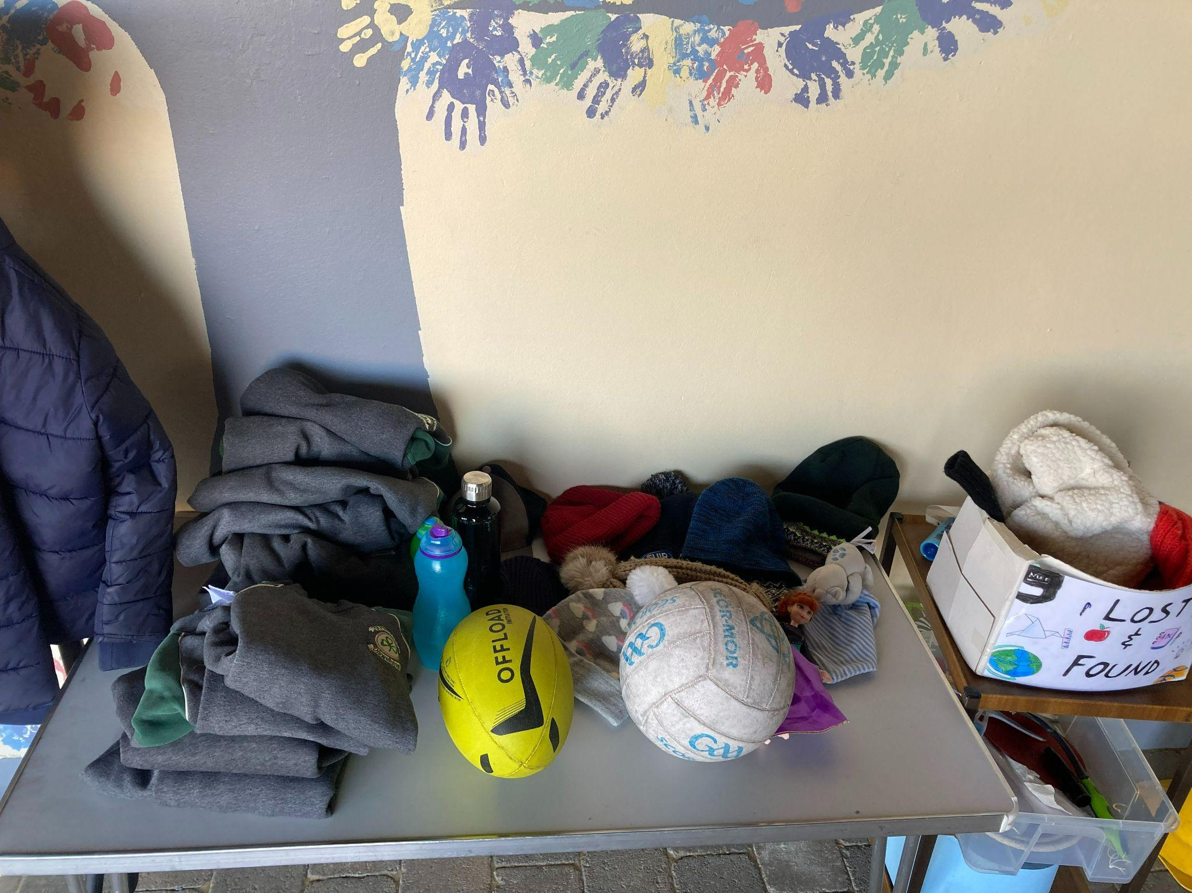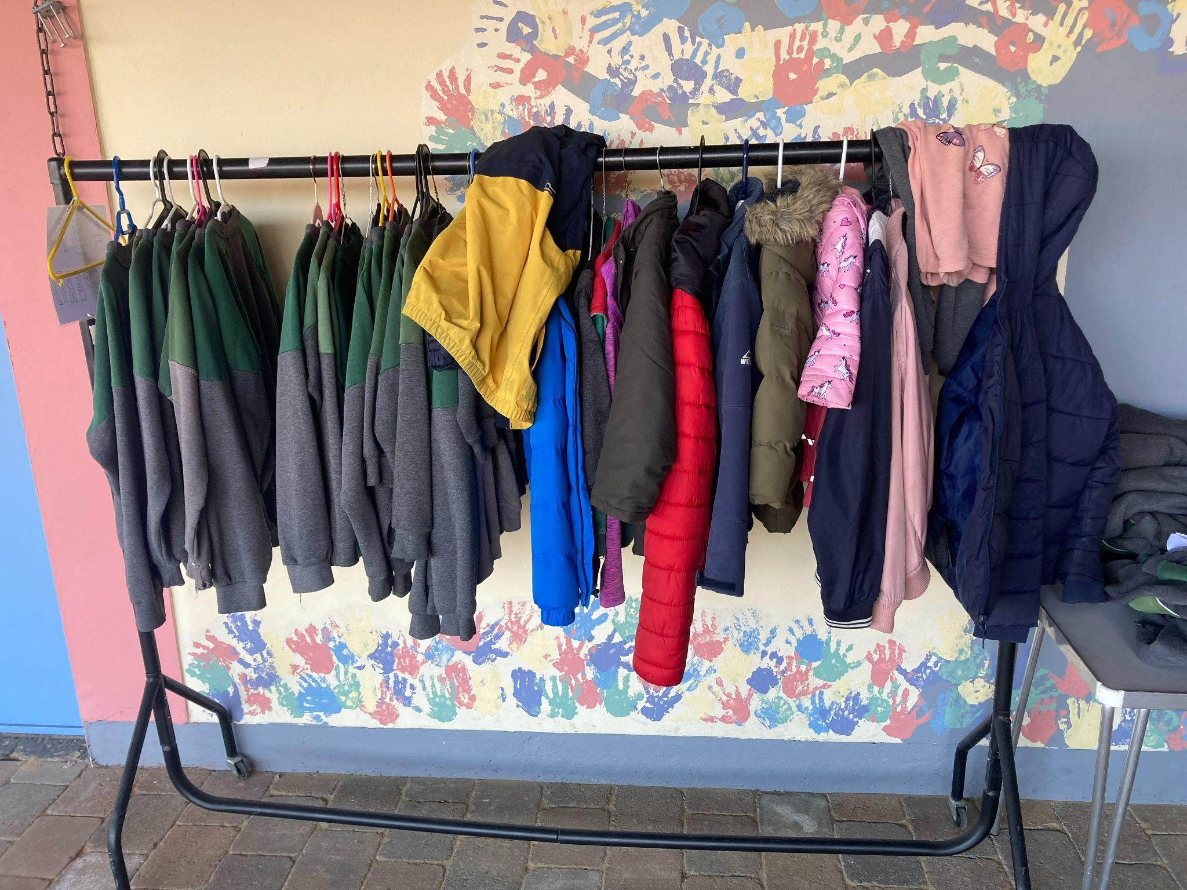
Reminders

Re-Registration for September 2022
Re-Registration Forms have been distributed to all children from Junior Infants to 5th Class. Thank you for returning your completed form. If you have not yet returned your form, we would greatly appreciate if you could do so ASAP. A copy of the form has been emailed to all parents so you can print out a new copy should the original be mislaid.
Extras Fees
Thank you to everyone who has paid their Extras Payment.
The Extras Payment of €75 per child is now payable through Aladdin. During the 2021/2022 school year, we rely on this for :
- Replacement of shared textbooks
- Classroom Resources for Literacy, Numeracy, Gaeilge, Science, History, Geography,PE, RE, SPHE, Visual Art, Drama and Music
- Stationery (pencils, crayons, copybooks, book boxes, etc) for all pupils.
- Photocopying
- Guided and Shared Readers, classroom novels
- IT Resources
- Insurance- 24 hour personal cover for all pupils (www.allianz.ie/schools) which costs €6.50 per pupil.
- Seesaw, Reading Eggs and Mangahigh subscriptions
We are a cashless school. Our Online Payment System allows parents to pay in a secure manner, using your ATM/Debit/Credit card. It will also automatically enter the record of the payment against your child's record on our school database. An email or text will issue to parents with all outstanding payments automatically listed.
We have set up the payment request so that you can pay in instalments if you wish. When you click into the link, there will be a payment on the screen for €75 for Extras Payments 2020-2021. Under the €75, you will see the word "change". Click on "change" and input the amount you wish to pay at this time. Minimum payment is €10 per each installment.
Aladdin Connect – Permissions
Permissions Requests are made throughout the year for various reasons. It is very important that when Permission requests are made that they are responded to promptly by either ticking “consent” or “decline”. Thank you for your cooperation in this matter.
Letters of Attendance
We would ask that if you require Letters of Attendance for Child Benefit/Travel/Visa purposes for your child/children, that you give the office as much advance notice as possible. Please EMAIL your request to info@stpatricksns.ie stating the purpose of the letter.

Returning to school or childcare after testing positive
Your child can return to school or childcare when both of these apply:
- they have not had a high temperature (38 degrees Celsius or over) or other symptoms for 48 hours
- it has been 7 days since they first developed symptoms
- When they stop self-isolating after 7 days, they need to take extra care for another 3 days to reduce the risk of passing COVID-19 on.
Selection of children for school events and appropriate parental interaction
The school leagues have started recently. Many thanks to all of our parents for your continued support of our school teams. We greatly appreciate your help with supervision, jersey care, side-line encouragement, etc. The school is indebted to our teachers who train and run the teams in a voluntary capacity. The school ethos is to promote ‘Sport for All’. However, some events are competitive and for these, children need to be selected. We always endeavour to be as fair as possible when picking children to represent the school.
It is not appropriate for parents to take issue with teachers regarding the selection process.
While there will always be differing opinions in this regard, it is the prerogative of the team management to make the final decision.
We look forward to another great year for St Patrick’s on the sporting field.
Extra Curricular Activities
IRISH DANCE CLASSES
Downey Lanigan Academy of Dance: Time to sign up for dancing. Irish dance is more than just learning steps, it builds confidence, strength, teamwork and so much more. Tuesdays after school, 1.10 (collected from class) and 2.10, in Saint Patrick's NC. Additional classes available for enquiries or to Register today email downeylanigan@gmail.com to avoid disappointment, places limited.
Table Tennis
Table Tennis is offered for children aged 6-13 years on Wednesdays after school in the School Hall at a cost of €75 for 10 lessons.
website : dublin-tabletennis.com
Session 1 at 02:10 pm to 3:05 places are limited.
Session2 from 3:10 pm to 4:05pm
To secure your place, please text your child’s name and class to
Tibor at 085 107 9317 or email tabletennis.ttt@gmail.com for further details.

Piano lessons
Available at St. Patrick’s School N.S. during academic year
Our team of professional piano teachers provide high quality lessons to students of all levels and ages. Whether sitting graded exams or taking lessons for fun, our students thrive in the relaxed and enjoyable atmosphere our experienced tutors create.
During the month of June trial piano lessons are available for children and adults.

Book your trial piano lesson now! Spaces are limited!T&C applies

Children’s piano lessons, beginner to advanced
Adult lessons for late beginner OR advanced student
Sit the RIAM graded exams
Pop music and Ear Training
Leaving Cert & Junior Cert Practical Repertoire

Anna Lewkowska 089-9533996
stpatrickpianoschoolofmusic@gmail.com

Diswellstown Community Centre & Local Area Activities

CASTLEKNOCK GAA

Sports in Tir na nÓg Park (D15 A996) every Thursday from 6.30pm to 7.30pm for Children recently arrived from Ukraine aged 5years+ (must be accompanied by an adult or guardian). On arrival sign up at registration table. Minibus leaves travel Lodge at 6pm or from Blanchardstown Shopping Centre take 37 Dublin Bus to stop 4893. Looking forward to welcoming you.

SELF ESTEEM, THE KEY TO YOUR CHILD’S FUTURE

6-week Parenting Classes Starting Monday the 9th of May 7pm - 9pm at Our Ladys Parish Centre, Beech Park Lawn, Castleknock.

For more information and to book a place go to happychild.ie.

A child’s personal and academic progress is influenced strongly by how that child sees him or herself. This course is a must for parents concerned about their children’s happiness and contentment with life!

Elaine Lynch-BSc: Psychotherapy. Dip: Parent Mentoring. Dip: Play Therapist.

